

**METROPOLITAN STATE UNIVERSITY**

**BACHELOR OF SCIENCE IN COMPUTER SCIENCE**

**FINAL YEAR PROJECT REPORT**

**E.M.S**

**EMPLOYEE MANAGMENT SYSTEM**

**STUDENTS NAMES:**

**Dilli Khatiwoda**

**Iiman Abdi**

**Maamoun Slayhi**

**Sapana Kunwar**

**December 2022**

“I hereby declare that I have read this project report and in my opinion this report is sufficient in terms of scope and quality for the award of the degree of bachelor’s in computer science

Signature : ....................................................

Supervisor :

Date :

**FINAL YEAR PROJECT REPORT**

**E.M.S**

**Employee Management System**

**STUDENTS NAMES:**

**Dilli Khatiwoda**

**Iiman Abdi**

**Maamoun Slayhi**

**Sapana Kunwar**

**A report submitted in partial fulfillment of the requirements for the award of the Bachelor of Science in**

**“Computer Science and Computer Information Technology” Major taken**

**College of Science,**

**Computer Science and Cybersecurity**

**December 2022**

**DECLARATION**

I declare that this thesis entitled “E.M.S Employee Management System” is the result of my/our own research

except as cited in the references. The report has not been accepted for any degree and is not concurrently

submitted in candidature of any other degree.

Signature : ....................................................

Name : Dilli Khatiwoda, Iiman Abdi, Maamoun Slayhi, Sapana Kunwar

Date : 12/10/2022**ACKNOWLEDGEMENT**

**ABSTRACT**

Now more than ever users want unified platforms, this project name E.M.S is designed to be an advanced employee management system, whichever company that uses this software will have the ability to manage employees’ hours, PTO, and allow the employee to view role and responsibilities, and what benefits does the company provide for them. E.M.S will allow department managers access to employee information and view their hours, PTO requests and feedback all in one place. E.M.S will also allow Human Resources administrators access to all employee data and their feedback to the company.

E.M.S requirements came about from company needs for such systems, it took what other similar systems did and where they lacked and enhanced on them where possible.

At this time, we will be working on a prototype that will showcase our idea and guide the build.

Table of Contents

INTRODUCTION 9

2.0 VISION AND BUSINESS CASE AND SCOPE 9

2.1 VISION 9

2.2 BUSINESS CASE 10

2.3 SCOPE 10

3.0 *FEASIBILITY STUDIES* 10

3.1 Proposed system functionalities 11

3.2 Problem Statement 12

3.3 Goals 12

3.4 The Requirements study 12

4.0 DETAIL DESIGN 13

4.1 Gathered requirements 13

4.2 Prototype 14

5.0 SYSTEM DESIGN 16

5.1 SYSTEM 16

5.1.1 USE CASE DIAGRAM 16

5.1.2 SYSTEM USER EMPLOYEE AND MANAGER 16

6.0 SEQUENCE DIAGRAM 21

6.1.0 SYSTEM EMPLOYEE USER 21

6.1.1 SYSTEM MANAGER USER 23

6.1.2 SYSTEM HUMAN RESOURCES USER 24

6.1.3 SYSTEM SITE ADMIN USER 25

7.0 INTERFACE DESIGN 26

8.0 DATABASE 26

9.0 CLASS DIAGRAM 28

9.1.1 SYSTEM EMPLOYEE USER 28

9.1.2 SYSTEM MANAGER USER 29

10.0 PROJECT SYSTEM 30

10.1.1 SYSTEM FUNCTIONALITY 30

11.0 SYSTEM REQUIREMENT 33

11.1.1 SOFTWARE REQUIREMENT 33

11.1.2 HARDWARE REQUIREMENT 33

12.0 SYSTEM IMPLEMENTATION 34

12.1.1 SYSTEM EMPLOYEE USER 34

13.0 SYSTEM MODIFICATION 36

14.0 SYSTEM LIMITATION 36

15.0 SYSTEM FUTURE ENHANCEMENT 37

16.0 PROJECT SCHEDULING 37

16.1.1 SCHEDULING TASKS DURATION 37

16.1.2 PROJECT TIMELINE 39

17.0 CONCLUSION 40

18.0 REFERENCES 40

19.0 APPENDIX 1 41

**LIST OF TABLES**

|  |  |  |
| --- | --- | --- |
| **NO** | **TABLES** | **DESCRIPTION** |
| 1 | Use Case Diagram | Diagram showcasing the use cases for each user according to their role |
| 2 | Task Duration | Duration for each proposed task to get to the final product |
| 3 | Task Distribution | Distribution of responsibilities across team members |
| 4 | Project Timeline | Anticipated timeline to reach deliverable product |

**LIST OF FIGURES**

|  |  |  |
| --- | --- | --- |
| **NO** | **FIGURES** | **DESCRIPTION** |
| 1 | Figure 1.0 |  |
| 2 | Figure 1.1 |  |
| 3 | Figure 1.2 |  |
| 4 | Figure 2.0 | Employee Use Case Diagram |
| 5 | Figure 2.1 | Manager Use Case Diagram |
| 6 | Figure 2.2 | HR Use Case Diagram |
| 7 | Figure 2.3 | Site Admin Use Case Diagram |
| 8 | Figure 2.4 | Employee Sequence Diagram |
| 9 | Figure 2.5 | Manager Sequence Diagram |
| 10 | Figure 2.6 | HR Sequence Diagram |
| 11 | Figure 2.7 | Site Admin Sequence Diagram |
| 12 | Figure 3.0 |  |
| 13 | Figure 3.1 | Class Diagram |
| 12 | Figure 3.2 |  |
| 14 | Figure 4.0 | Login Page |
| 15 | Figure 4.1 | Landing Page |
| 16 | Figure 4.2 | Feedback Page |
| 17 | Figure 4.3 | Home Page |
| 18 | Figure 5.0 |  |
| 19 | Figure 5.1 |  |
| 20 | Figure 5.2 |  |
| 21 | Figure 5.3 |  |
| 22 | Figure 5.4 |  |
| 23 | Figure 5.5 |  |
| 24 | Figure 5.6 |  |

# INTRODUCTION

E.M.S stands for Employee Management System, this is a project proposed and created by the following students for the senior year capstone, Maamoun Slayhi, Sapana Kunwar, Iiman Abdi, and Dilli Khatiwoda. Our goal is to create an employee management system to be provided as a SaaS (Software as a Service) to any company that is trying to simplify access to benefits, hours, and employee information all in one place and efficiently.

This system does not only work as a timekeeper for all employee hours but also a place to gather more information about specific role, other employees, personal information and benefits, it is also a place where the company can gather feedback for their employees. Department managers will have the ability to see the hours worked for their direct reports, see any PTO request, and approve/decline the request and assign work hours if needed. E.M.S is accessible from anywhere their internet and from any device that is a smart device such as smartphones, tablet, computer. E.M.S is meant to replace multiple platforms and combine them into one, those platforms are, employee work hours, employee feedback, direct report rosters, paystub information, PTO requests, and benefits communications.

# 2.0 VISION AND BUSINESS CASE AND SCOPE

## 2.1 VISION

Our objective is to design a comprehensible and coherent employee management system to help a business run more smoothly. Some of the goals of an employee management system include assisting in raising employee productivity, figuring out how to attract and retain talent through feedback, and lowering the administrative burden on HR professionals with an easy-to-understand application. We hope that in creating this E.M.S there is not only an open line of communication with both employees and hr but better experience overall.

## 2.2 BUSINESS CASE

Many companies are aware of the risks associated with the current employee management systems. While some businesses still use the paper route, for tasks like payroll information. Timecards and spreadsheets are not the most dependable way to get this data, as we all know. In the event that an employee forgets to clock in or out for their shift or breaks, timecards may not be accurate. Relying solely on an employee's memory can lead to pay mistakes and create issues for the payroll department. On the other hand, many businesses have moved some of their managerial activities online. Although even if a company has resolved this issue and implemented this system online, it may still need to deal with other systems. Utilizing multiple methods to manage personnel is not very effective, since it needs ongoing, potentially costly maintenance on a large number of systems. You could save a substantial amount of money by using a fully-featured system.

## 2.3 SCOPE

This system's creation had several objectives, including enabling employees to access their information, hours, and PTO while also giving management and business feedback. This will allow us to use that information to improve their experience. We also hope to have a page that shows the most recent updates or any changes to either the business or the website. Along with that information we will display the mission and vision statements. We want to make management informed of the working hours, PTO requests, and other managerial responsibilities.

# 3.0 *FEASIBILITY STUDIES*

**The project study can be performed in two ways such as technical feasibility and Economical Feasibility.**

**Economic Feasibility:**

This employee management system is simple and easy to use which will help many big and small organizations to organize all their employee related work at one pace and will save so much time for manager and HR.

The project has shown the economic feasibility by the study of the fact that using this software increases the number of consumers who can access the service effectively, efficiently and can save a lot of time and saving time means saving operational cost.

**Technical Feasibility:** Just like any other websites EMS can be accessible through any computer or phone with just the internet connection so won’t cause technically issue.

## 3.1 Proposed system functionalities

The main functionality of the Employee Management System is to supervise and manage employee activities, their associated benefits, and their feedback for the company efficiently. This project intends to build an advanced management system in which all the relevant information on a company’s human resources is consolidated. This reduces the paper workload and human error in the employee management process. Also, this system will allow all employees to access and view their information associated with the company from anywhere, anytime, and from any modern computing devices including smartphones provided internet access.

## 3.2 Problem Statement

Problems the E.M.S aims to solve include HR being compelled to shuffle among different applications to view employees’ general information such as worked hours, overtime, paid time off and holiday hours, paid time off requests/approval/denial, address, emergency contact, and so on. Managers often encounter interruptions, amidst their important duties, from employees requesting to provide them with their paystubs, and information to their health insurance access, retirement benefits information, paid holidays, and so on. E.M.S intends to address such inconveniences by consolidating everything into one place and providing every access the employees need at the tip of their fingers.

## 3.3 Goals

The goal of this project is to build a system that consolidates all the problems mentioned in the problem statement into a single webpage application. To accomplish this, all the requirements will be gathered prioritizing the user-friendly and easy-to-use interface. Meanwhile, time constraints and the project feasibility will be considered to accomplish our goal as desired.

## 3.4 The Requirements study

***Software Development Methodology – AGILE***

We are following agile methodology here in our project which is an iterative and incremental approach. Iterative means the same process will be repeated and again. Which means we gather the requirement, design, develop and testing will be done. This process of requirement .design, develop and test will keep on repeating.

Incremental means module will be kept on adding. Which means features will be added. And the company should be flexible enough to accept those changes.

So, our project should be flexible enough to accept those changes and deliver the project on time. In agile methodology all the team will be working together so there will be a good flow of communication.

Requirement Gathering

Design

Development

Testing

# 4.0 DETAIL DESIGN

TO BE CREATED PART OF ITERATION 3

Figure 1.0

Figure 1.1

## 4.1 Gathered requirements

The initial conversations around EMS lead to the following preliminary requirements:

1. Time keeping functionality and Paid Time Off requests capability.
2. Manager and HR admin access to see more information per employee and edit as needed.
3. Historical/archived hours worked and feedbacks provided.
4. Provide access to paystub and role information plus responsibilities related to it.
5. Home page with clear indication of who is logged in, with their information available for access.
6. HR capability to add and remove company information and benefits from the system.

## 4.2 Prototype

Figure 4.0 Login Page

Figure 4.2 Landing Page

Figure 2.3 Feedback Page

Figure 4.4 Home Page Menu

# 5.0 SYSTEM DESIGN

## 5.1 SYSTEM

## 5.1.1 USE CASE DIAGRAM

## 5.1.2 SYSTEM USER EMPLOYEE AND MANAGER

As shown below, all company users will login using the same login but each will have a specific role that allow them to see different information according to their provided role in the company.

Employee have limited access to the system where they are in view only mode of their information, have the capability to request paid time off, they can access paystubs and provide feedback to the company through a feedback portal. While managers have elevated accesses to system, where they can edit hours for their direct reports, approve or deny paid time off requests, see feedback from employees, set hours if needed for direct reports. Human Resources, will have an additional elevated access that allows them to insert new user information, add/remove company communications/ resources/ benefits, and finally the ability to respond the employee feedback.

Finally as expected all users will have the ability to logout using the same steps, and the system will have the ability to terminate the logged in session after the browser has been closed.

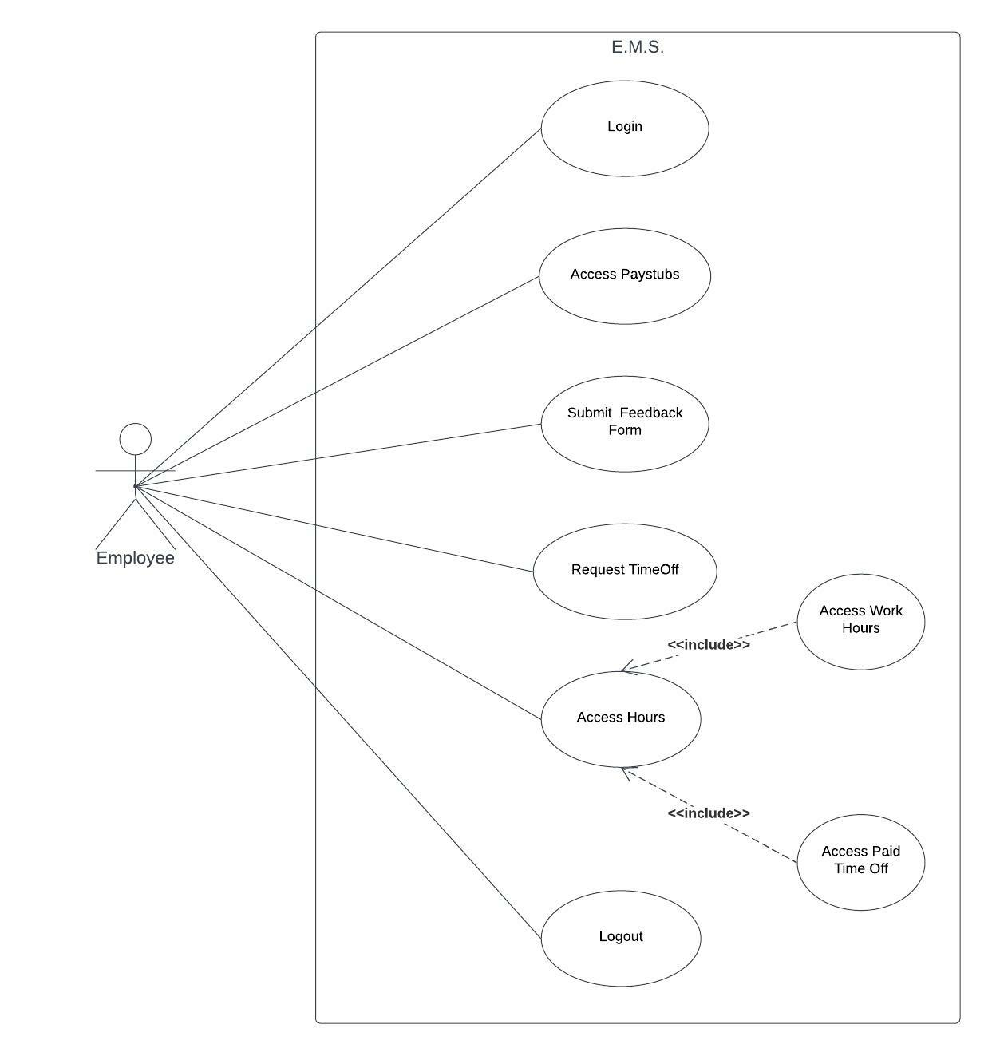

Figure 2.0 Employee Use Case Diagram

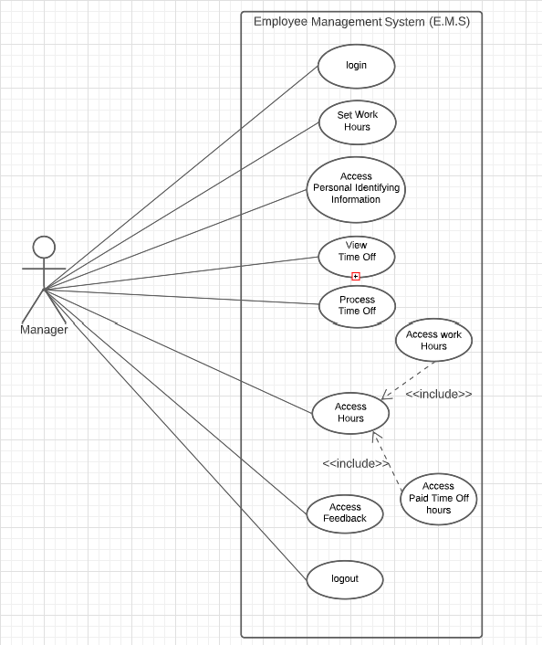

Figure 2.1 Manager Use Case Diagram

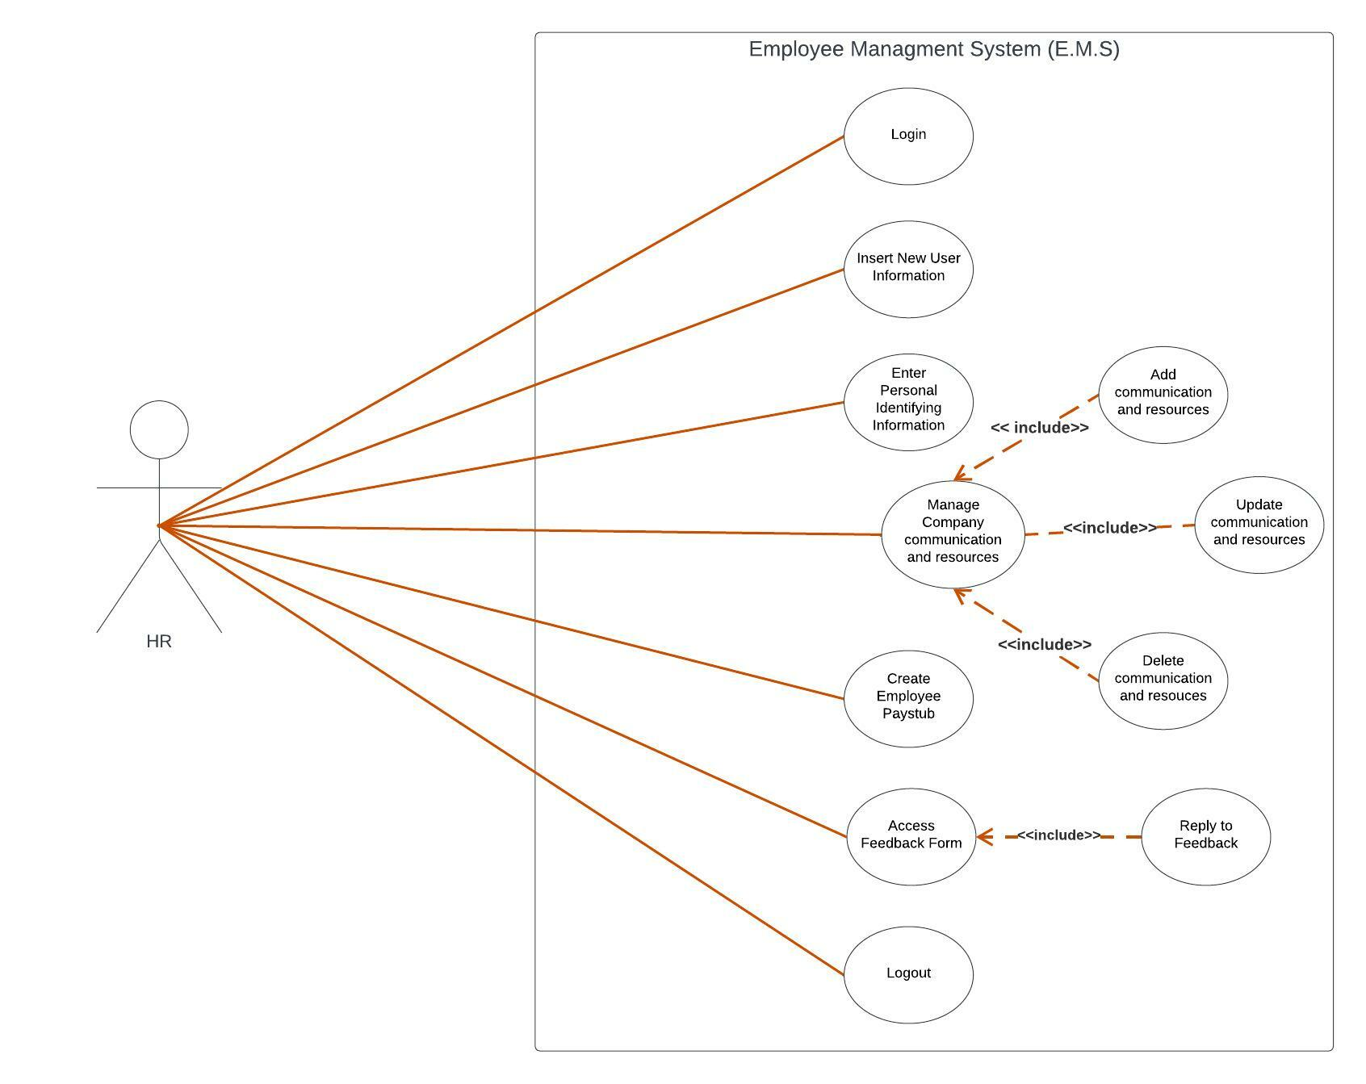

Figure 2.2 HR Use Case Diagram

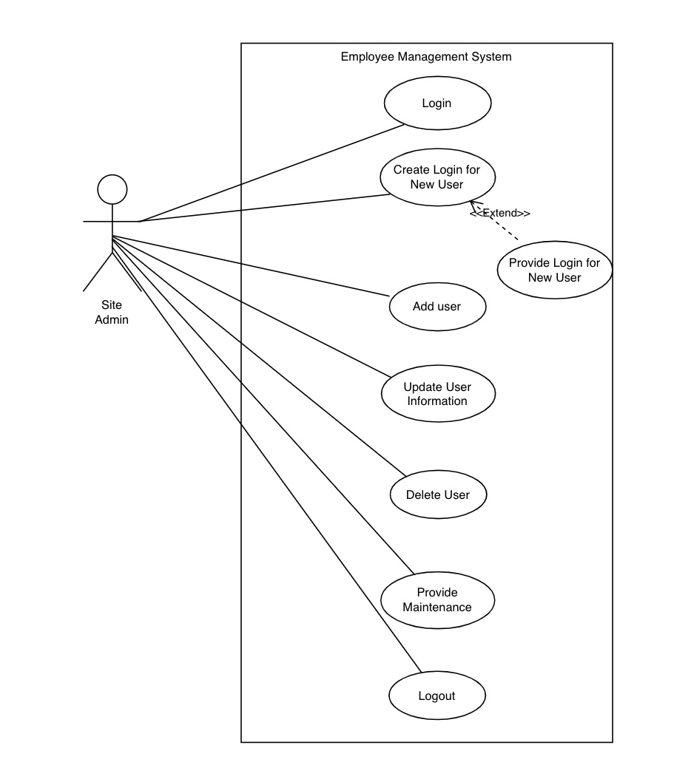

Figure 2.3 Site Admin Use Case Diagram

# 6.0 SEQUENCE DIAGRAM

## 6.1.0 SYSTEM EMPLOYEE USER

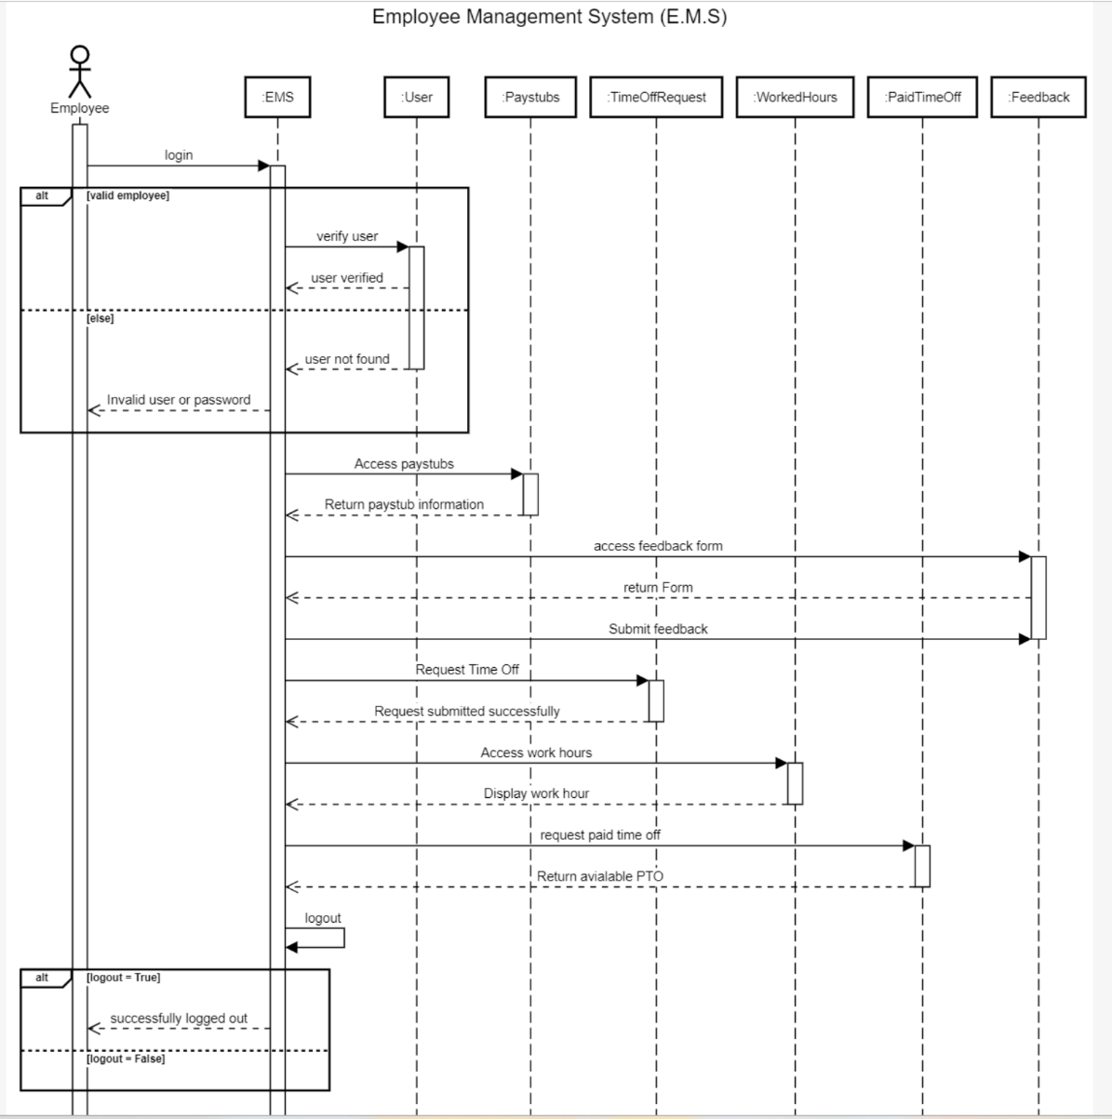

Figure 2.4 Employee Sequence Diagram

## 6.1.1 SYSTEM MANAGER USER

Figure 2.5 Manager Sequence Diagram

## 6.1.2 SYSTEM HUMAN RESOURCES USER

Figure 2.6 HR Sequence Diagram

## 6.1.3 SYSTEM SITE ADMIN USER

Figure 2.7 Site Admin Sequence Diagram

# 7.0 INTERFACE DESIGN

Figure 2.3 Overview of Interface

**SYSTEM EMPLOYEE USER**

Figure 2.4 User interface

**SYSTEM MANAGER USER**

Figure 2.5 Admin Interface

# 8.0 DATABASE

This database diagram describes the detailed architectural design for the project

TO BE ADDED IN ITERATION 3

Figure 3.0

# 9.0 CLASS DIAGRAM

Figure 3.1 Class Diagram

## 9.1.1 SYSTEM EMPLOYEE USER

**Separation of the classes will be part of Iteration 3**

Figure 3.2

## 9.1.2 SYSTEM MANAGER USER

Figure 3.2

# 10.0 PROJECT SYSTEM

## 10.1.1 SYSTEM FUNCTIONALITY

Figure 4.0.

Figure 4.1

Figure 4.2

Figure 4.3

|  |  |
| --- | --- |
| Users/actors | Use cases/Functionalities |
| Employee | * Login * See hours worked and PTO * Access company resources * Access paystubs * Request Form (PTO, NPTO) * Company feedback form * logout |
| Manager | * Login * View all employees’ hours * view Personal Identifying information of direct reports * View Paid Time Off (PTO) requests * Respond with Approval or rejection * Assign Work Hours for each employee * Logout |
| HR | * Admin login * Make changes as needed to the site * Respond to feedbacks * Insert new hire information into system * Create paystub to employees * logout |
| Site Admin | * Super Admin login * Maintenance of site and access * Delete/add/update users * Provide new user with login information * logout |

Table 1.0 Use case diagram table

# 11.0 SYSTEM REQUIREMENT

## 11.1.1 SOFTWARE REQUIREMENT

**User:**

* + - Operating System Environment: Windows 10, 11 (Home,Pro,Enterprise), Lynx, OSX
    - Front End HTML, PHP, CSS, JavaScript
    - Back End PHP, MYSQL Database

## 11.1.2 HARDWARE REQUIREMENT

**User:**

* + - CPU: Minimum setup with 4 Cores
    - RAM: Minimum 8 GB
    - Hard Disk space: Minimum 40 MB

# 12.0 SYSTEM IMPLEMENTATION

## 12.1.1 SYSTEM EMPLOYEE USER

Figure 5.0

Figure 5.1

Figure 5.2

Figure 5.3

Figure 5.4

**Create employee profile**

Figure 5.5.

Figure 5.6

# 13.0 SYSTEM MODIFICATION

# 14.0 SYSTEM LIMITATION

# 15.0 SYSTEM FUTURE ENHANCEMENT

# 16.0 PROJECT SCHEDULING

## 16.1.1 SCHEDULING TASKS DURATION

|  |  |
| --- | --- |
| **TASKS** | **DURATION** |
| Project Proposal:   * Propose a project. * Update project description. * Update scope, vision, and mission * Define requirements. * Create use cases. | First three weeks.  08/26/2022 - 09/18/2022 |
| Diagrams:   * Create class, sequence, and activity diagrams. * Prototype creation for visual understanding of the project | Two weeks  09/19/2022 - 10/03/2022 |
| Web page:   * Get the web page running. * Update front-end application. * Start on the database. | Four weeks  10/04/2022 - 10/31/2022 |
| Database and Testing:   * Back-end development. * Database integration. * Testing | Four weeks  10/31/2022 - 11/28/2022 |
| Submission:   * Prepare and submit all deliverables. | One week  11/28/2022 - 12/05/2022 |

Table 2.0 Task Duration

|  |  |  |
| --- | --- | --- |
| **ITERATION** | **TASK** | **TEAM MEMBER** |
| 1 | * Introduction, use case diagrams, Hardware/software requirements. * Vision and Scope, Business Value, Project log. * Feasibility studies, software development methodologies. * Proposed system functionalities, project plan. | * Maamoun Slayhi * Iiman Abdi * Sapana Kunwar * Dilli Khatiwoda |
| 2 | Sequence diagram, class diagram.  Work more on the front-end app and adapt the agile approach as the project progresses.  Get the website running.  Start working and integrating database.  Programming languages:   * PHP, JavaScript * JavaScript * HTML | Maamoun Slayhi,  Iiman Abdi, Sapana Kunwar,  Dilli Khatiwoda |
| 3 | Separate class diagram for each class.  Activity Diagram, Database Diagram.  Continue working on front end app and add more features.  More focus on back-end |  |
| 4 |  |  |

Table 3.0 Task Distribution

## 16.1.2 PROJECT TIMELINE

|  |  |
| --- | --- |
| Planning to develop a web application | * Requirements and Design Documents * Detailed Requirements |
| Testing | * Test plans * Test documentation |
| End User Documentation | * System Documentation * Class Diagrams * Activities diagrams * Sequence diagrams * Coding |
| Submission | * Final project in working order |

Table 4.0 Project Timeline

# 17.0 CONCLUSION

# 18.0 REFERENCES

**ONLINE ARTICLES**

**AUTHOR, (YEAR OF PUBLICATION). TITLE, VOLUMN NUMBER (ISSUE NUMBER IF ANY). RETRIEVED MONTH DAY, YEAR FROM URL

# 19.0 APPENDIX 1

**Snippets of the source code for EMS**

**